**Understand how to create HTML forms for user input.**

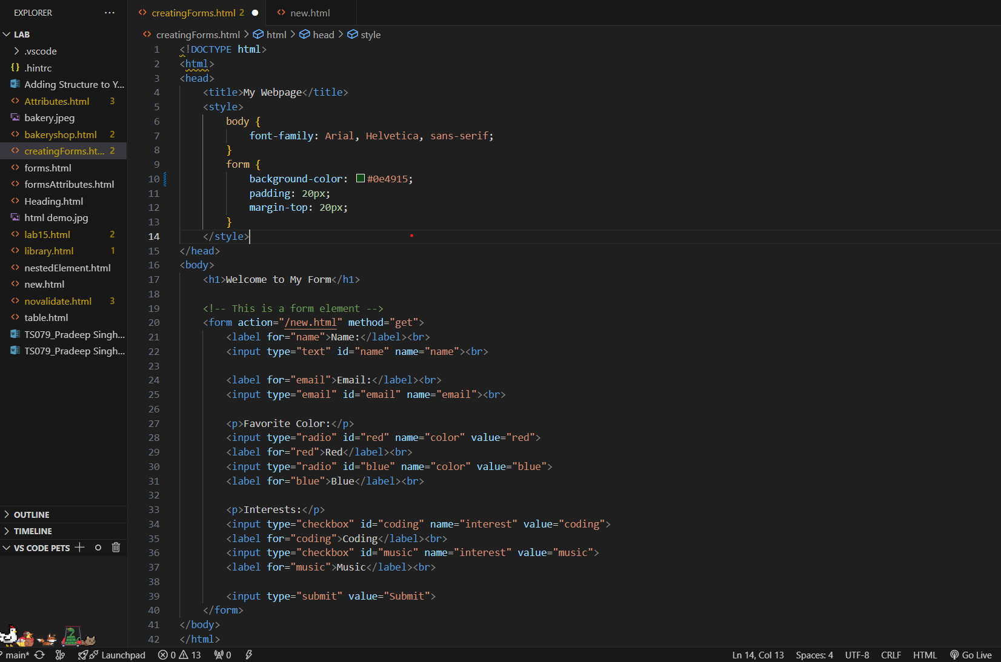

**Below are the steps followed to create this form:**

1.Open your HTML file in a text editor.

2.Add a form (<form>) element to your webpage.

3.Inside the form, include different types of form controls such as text inputs, radio buttons, checkboxes, and submit buttons. Use the <input> tag and specify the type of input with the type of attribute.

4.Experiment with form attributes like action and method. The action attribute specifies where to send the form data when the form is submitted, and the method attribute specifies how to send the form data.

5.Experiment with input attributes like type, name, and value. These attributes define the type of input and the data sent when the form is submitted.

6.Save the changes to your HTML file.

7.Open your HTML file in a web browser to see the updates. Refresh the webpage if it’s already open.

**Output:**

